

Machine Learning

MOD006562

**Azizjon Achilov**

SID: **2313111**

Faculty: Artificial Intelligence

School: Computing and Information Science

Academic Year: 2024/25

Trimester: 2

Contents

1 Introduction 3

2 Description of the Dataset 3

3 Data Analysis 3

4 Preparing Data 4

4.1 Data pre-processing 4

4.2 Vectorization 4

5 Training and Evaluating Models 4

5.1 [Model 1 – provide name of the model] 5

5.1.1 Describe your model. 5

5.1.2 Explain your evaluation design. 5

5.1.3 Present and explain results. 5

5.2 [Model 2 – provide name of the model] 5

5.2.1 Describe your model. 5

5.2.2 Explain your evaluation design. 5

5.2.3 Present and explain results. 5

5.3 [Model 3 – provide name of the model] 5

5.3.1 Describe your model. 5

5.3.2 Explain your evaluation design. 5

5.3.3 Present and explain results. 5

6 Evaluation Analysis 5

7. References 6

# Introduction



This document provides an overview of the AI response categorization model developed for the **Japeto Chat** platform. The model is designed to automatically categorize AI-generated chatbot responses with an **accuracy of at least 85%.**

To address this challenge, the developed model leverages a dataset of **1500 chatbot messages**, combining both scripted and AI-generated responses. The model is trained to recognize patterns in previously tagged messages and predict the most relevant category for new AI-generated responses.

# Description of the Dataset

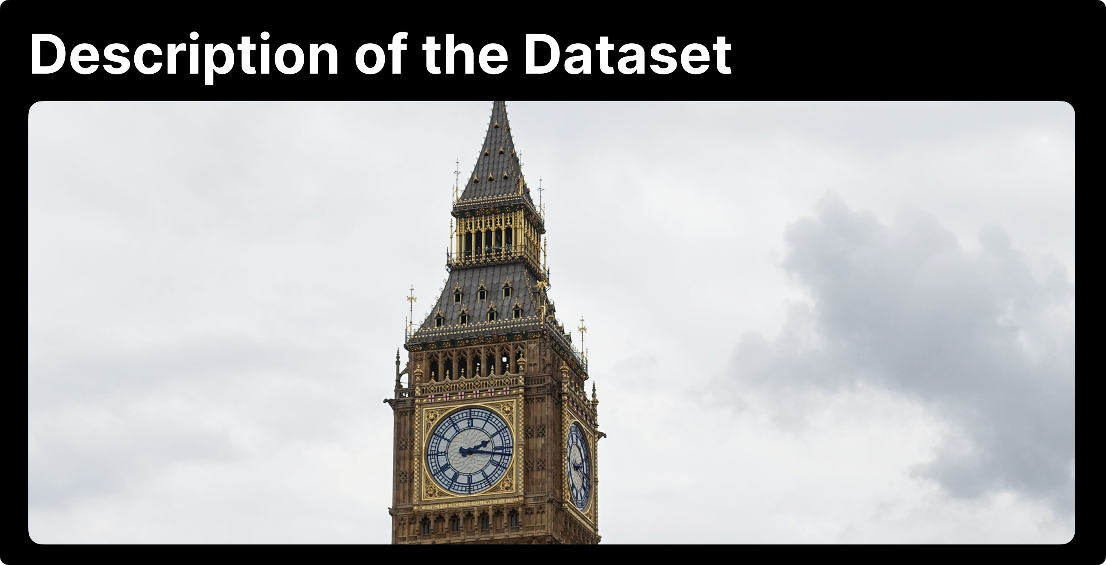

We have a small dataset consisting of 1,500 messages exchanged between users and an AI bot. Some of the dialogues were borrowed from the Paige bot (another Japeto project). It is also worth noting that the data consists of both real and artificially created dialogues, and all data complies with user privacy policies, meaning the file contains only real user dialogues without any personal information.

**Data Structure**

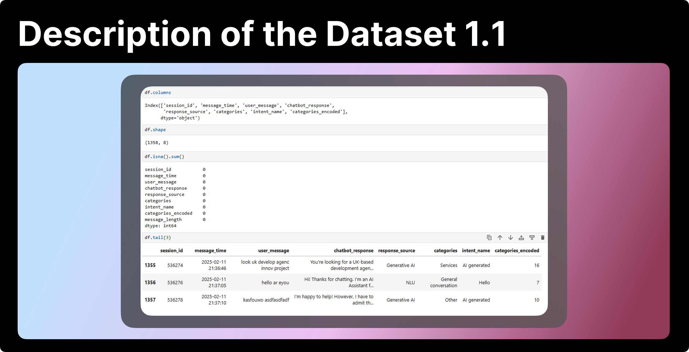

The dataset contains 1,500 messages. They represent a combination of scripted and AI-generated responses. Here is a brief visualization and some interesting statistics:

1. We have 9 columns (for us programmers, 0 is also a number and is usually the first one). We will use some of the columns, specifically those related to categories and chats between the user and AI.
2. We have 1,359 chats. This is not much, but we can allocate 80% for training and 20% for model testing.
3. The data is complete (there are no empty columns, as is often the case with incomplete data).
4. We can see that the final columns do not present any issues, indicating that the data is evenly and correctly filled. Also, I noticed that the data was collected over a short period, judging by the time column.

**Goal**

From this data, we need to build a machine capable of accurately categorizing messages. The machine should be fast enough for Japeto to use categorization in real-time.

# Data Analysis



Tasks

**Categories**

Determine the number of categories and make sure the classes are balanced.

**Common words and phrases**

Identify the most frequently used words and phrases in each category.

**Category Intersection**

Analyse category intersection - identify words and phrases that are repeated in multiple categories.

**Message Length and Complexity**

Assess message length and complexity. The word/character count ratio is examined.

**Category Distribution in the Dataset**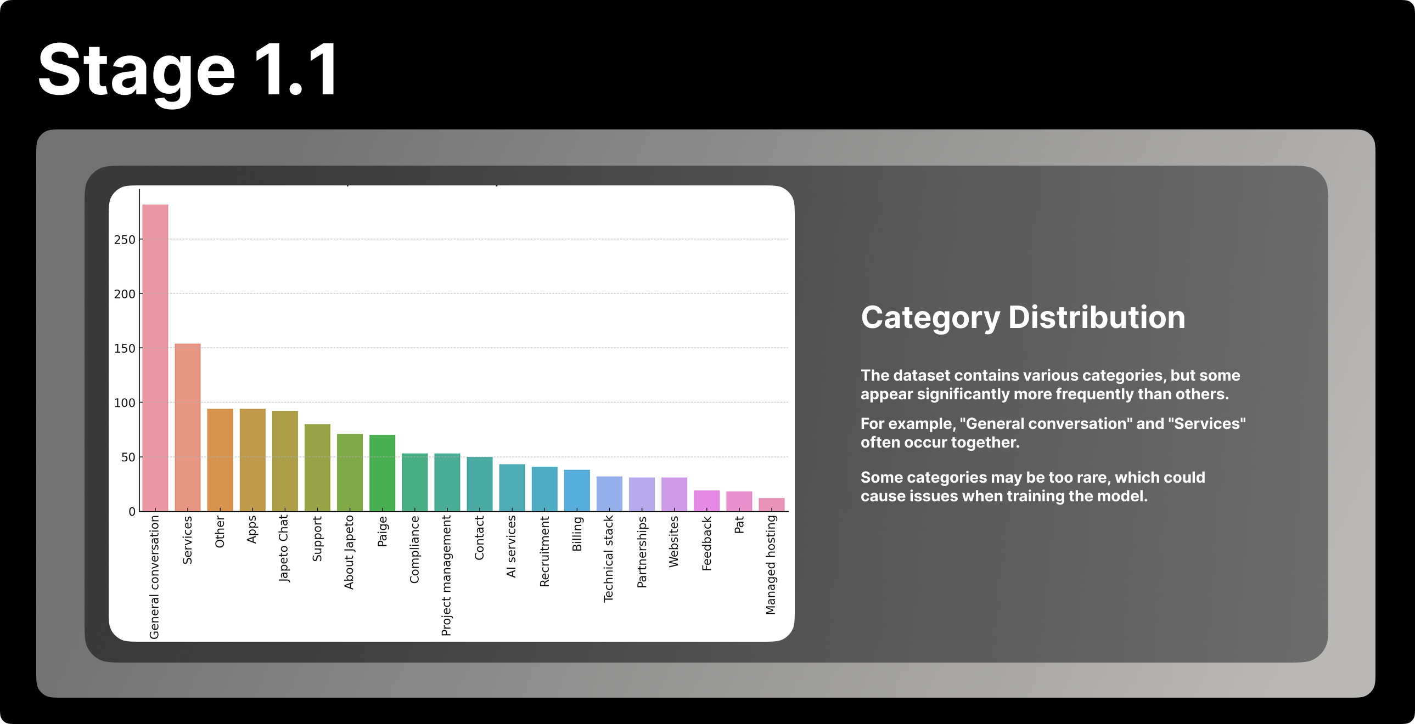

The dataset contains various categories, but some appear significantly more frequently than others.  
For example, "General conversation" and "Services" often occur together.  
Some categories may be too rare, which could cause issues when training the model.

**Word Cloud for User Messages**

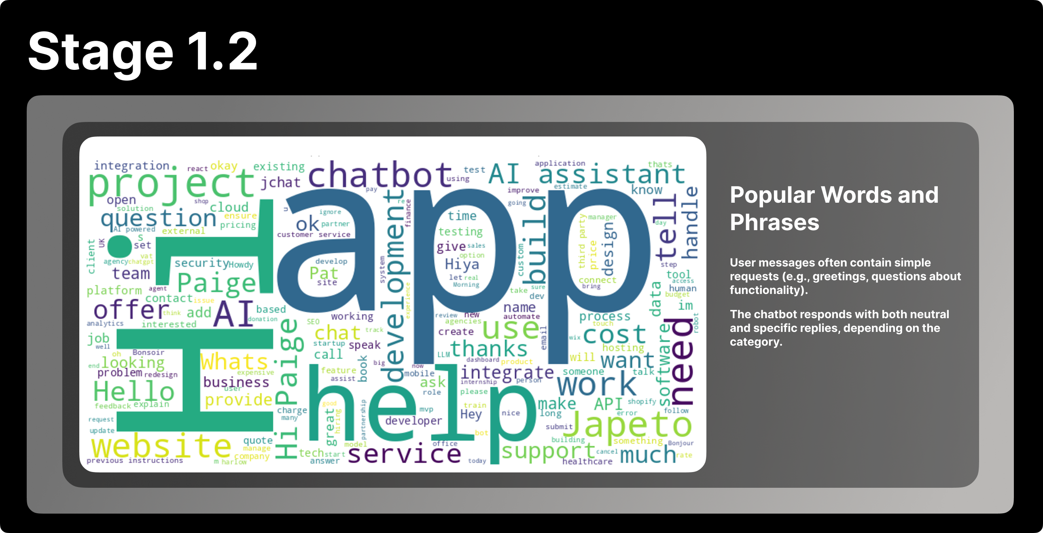

The dataset contains various categories, but some appear significantly more frequently than others.  
User messages often contain simple requests (e.g., greetings, questions about functionality).  
For example, "General conversation" and "Services" often occur together.  
The chatbot responds with both neutral and specific replies, depending on the category.  
Some categories may be too rare, which could cause issues when training the model.

Visualisation

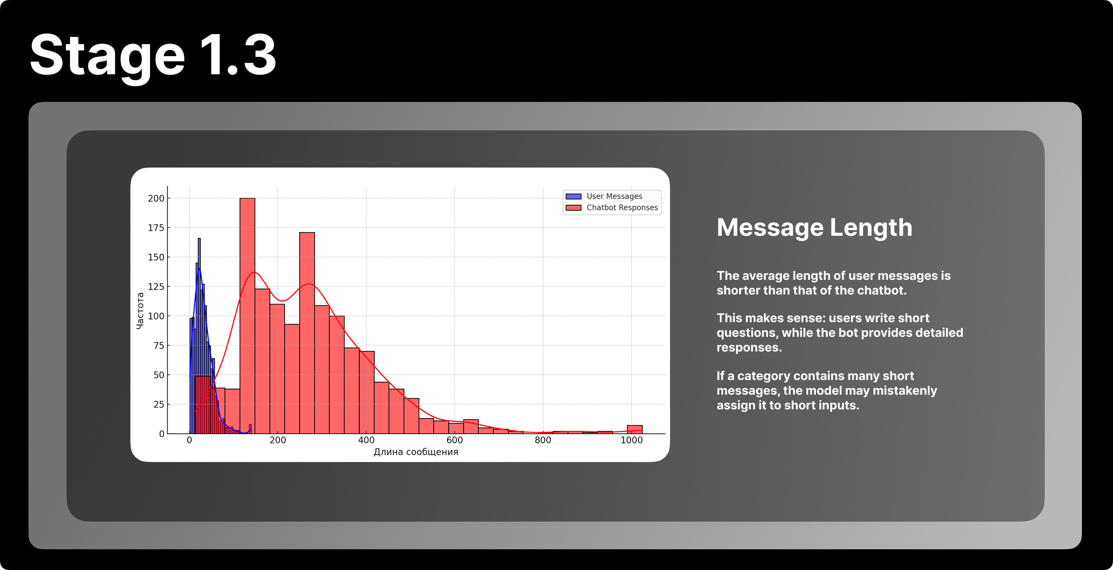The histogram plot shows the distribution of the length of user messages (in blue) and chatbot answers (in red). The X-axis shows the length of messages in characters, the Y-axis shows the frequency (the number of messages of a certain length).

Conclusion

If a category contains many short words, the classification model may erroneously assign any short message to it, even if it is not relevant to the essence of the category. This can lead to a bias in the model's predictions. Therefore, it is essential to consider the length of messages as a factor that may affect the quality of classification.

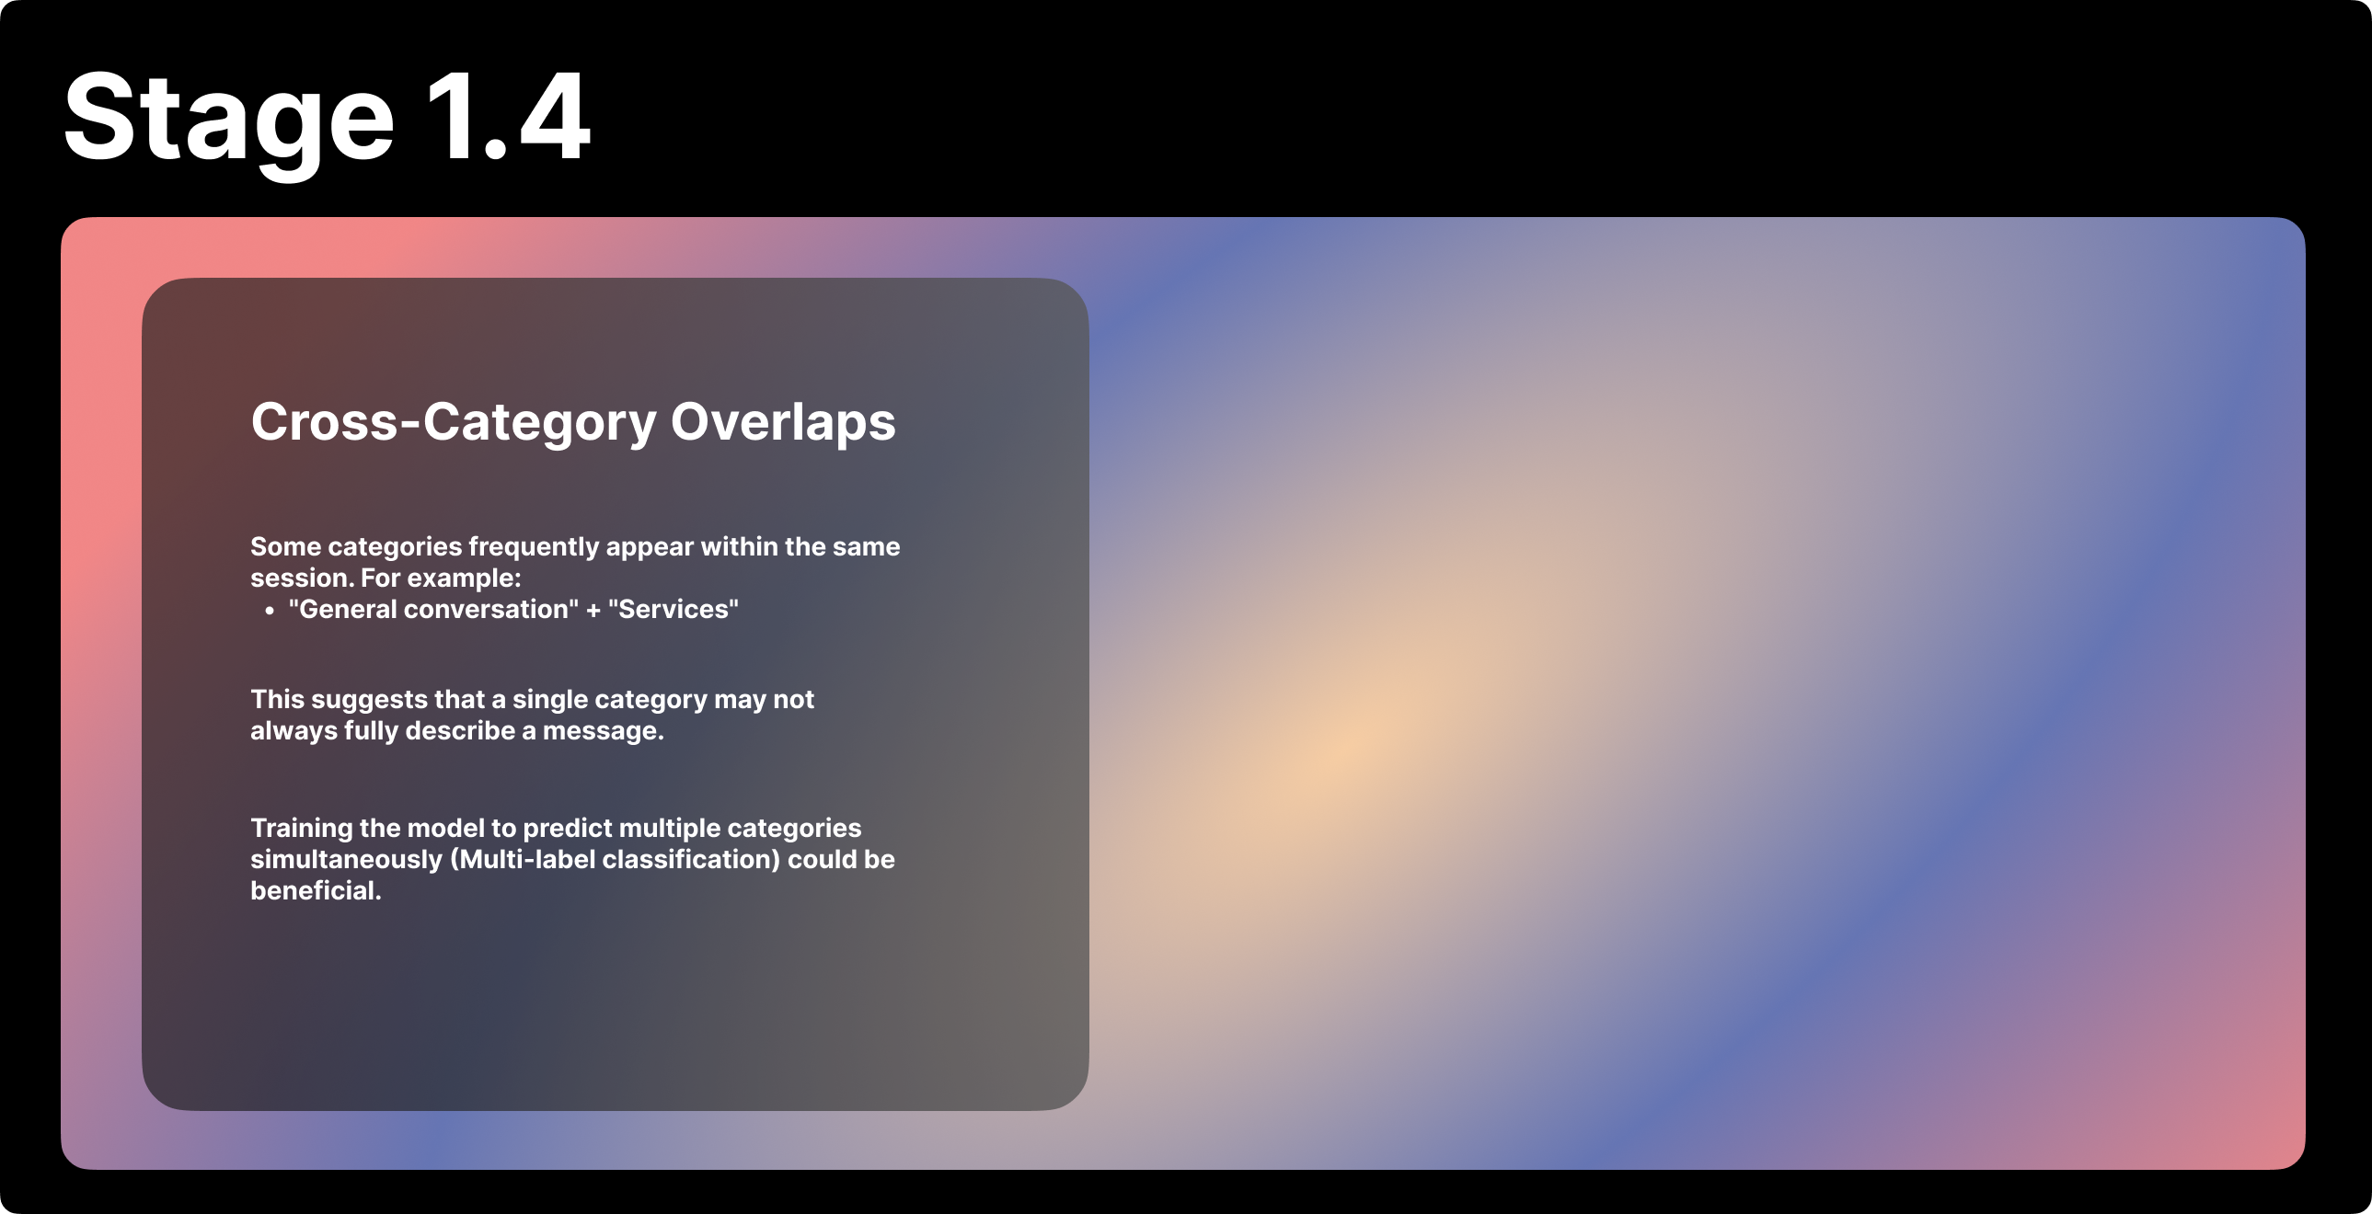

A model restricted to selecting only one category may misinterpret the context. Therefore, a logical solution is to use multi-label classification, where a single message can be classified into several categories.

# Preparing Data

## Convert category labels (e.g., “Support”, ‘Billing’, “Reviews”) to numeric values (e.g., 0, 1, 2).

This is necessary because the model works with numbers, not strings.

**Feature engineering**

Feature engineering is the process of selecting, manipulating and transforming raw data into features that can be used in supervised learning.

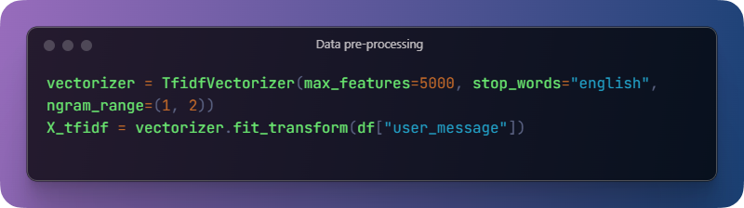Converts the text of a user_message message into a number of TF-IDF attributes.

**TF-IDF (Term Frequency-Inverse Document Frequency)** measures how important a word in a message is relative to all messages.

**max_features**=5000 limits the vocabulary to 5000.

**stop_words="english"** removes common words such as "is", "the", "in" and parasite words.

**ngram_range=(1, 2)** includes both single words (unigrams) and pairs of words (bigrams).

**Balancing Classes with Oversampling**

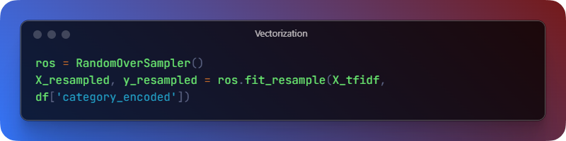Solves the problem of class imbalance (when some categories occur much more often than others).

**RandomOverSampler** creates duplicate examples from minority classes so that all classes have the same number of examples.

This helps prevent the model from biasing towards majority classes.

**Train-Test Split**

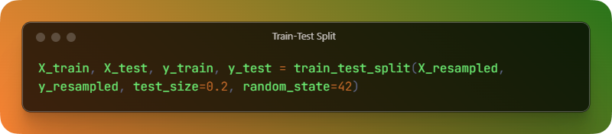Splits the data into training (80%) and test (20%) sets.

This allows training the model on one part and evaluating it on another, unseen part. random_state=42 ensures repeatability (same partitioning every time).

**SVM(**Support Vector Machine**)**

A support vector machine (SVM) is a [supervised machine learning](https://www.ibm.com/topics/supervised-learning) algorithm that classifies data by finding an optimal line or hyperplane that maximizes the distance between each class in an N-dimensional space

SVMs are commonly used within classification problems. They distinguish between two classes by finding the optimal hyperplane that maximizes the margin between the closest data points of opposite classes. The number of features in the input data determine if the hyperplane is a line in a 2-D space or a plane in a n-dimensional space.

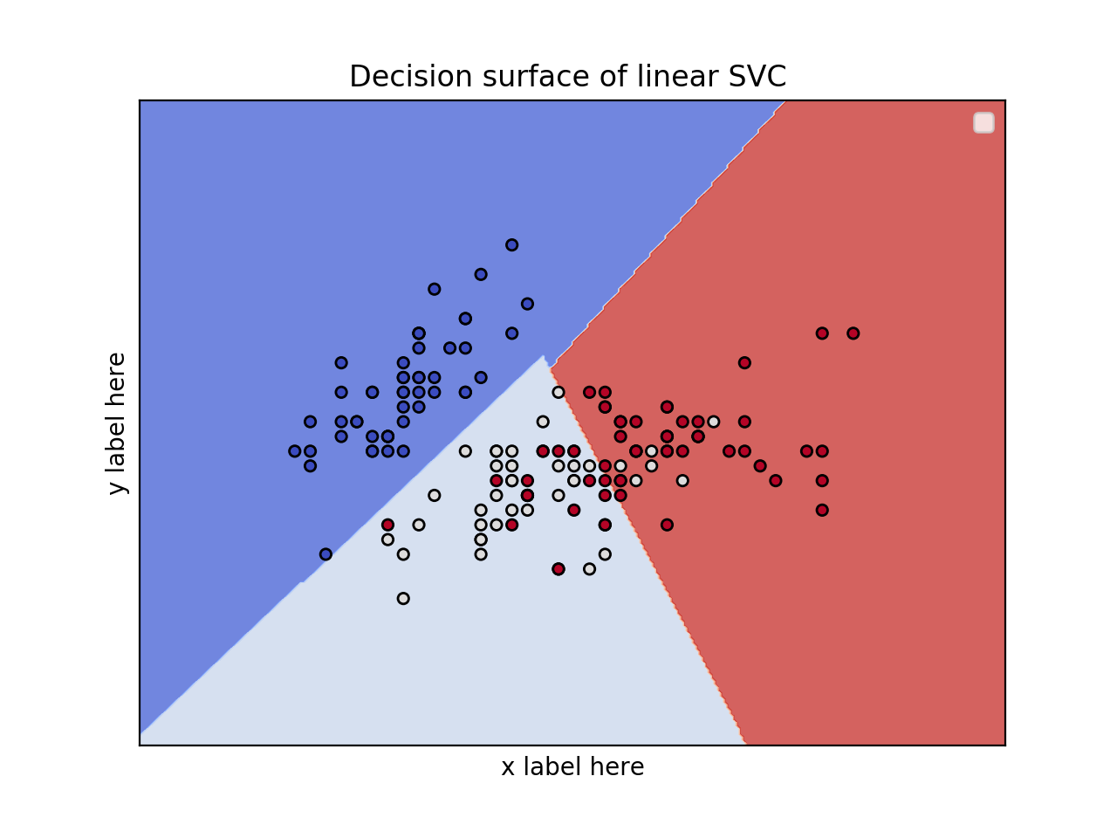**I used this training method because many sources indicate that this method is very effective in classification tasks**.

**SVC model**

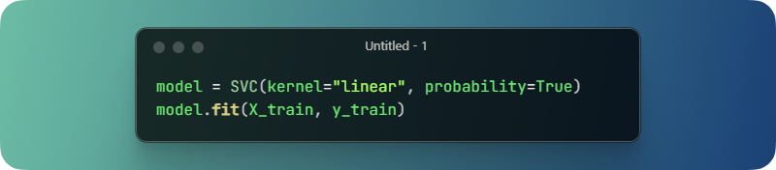**The SVM (Support Vector Machine)** model is created using a linear kernel.

**probability=True** allows the model to return class probabilities, which can be useful for confidence estimation or multi-class strategies.

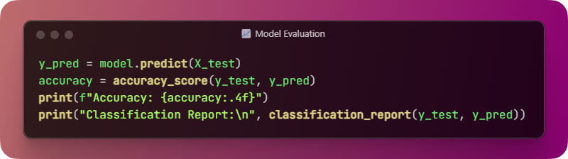Accuracy is calculated - it shows the percentage of correct predictions.

The classification report displays detailed metrics for each class:

Accuracy: How many predicted labels were correct.

Recall: How many real labels were correctly predicted.

F1-score: The harmonic mean of the precision and recall scores.

**Results**

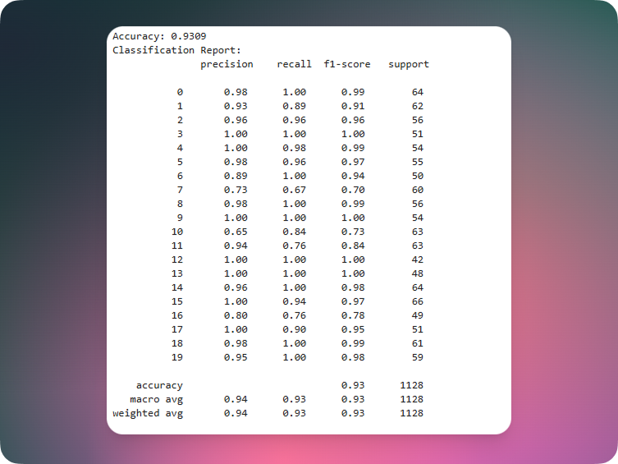

**The Support Vector Machine (SVM)** model performed well when classifying user messages into 20 categories.

**Accuracy**: 93% - most messages were categorised correctly.

**Macro F1-score**: 0.93 - good average performance across all classes.

**Weighted F1-score**: 0.93 - performance remains high even with different class sizes.

**Class performance**

Many classes were predicted almost perfectly

A few classes (e.g. **class 7 and class 16**) performed lower, meaning that the model sometimes confused them with others.

For example, for class 7, the recall rate was 0.67, meaning that the model missed some correct examples.

**Model Speed Test**

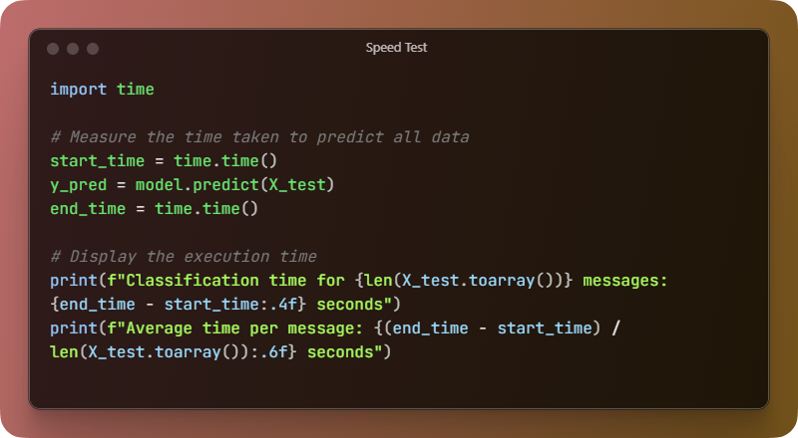**Classification time** for 1128 messages: **0.0911 seconds**  
**Average time** per message: **0.000081 seconds**

**I tried to improve the class 7 and 10 prediction but I failed, I only made the result worse.**

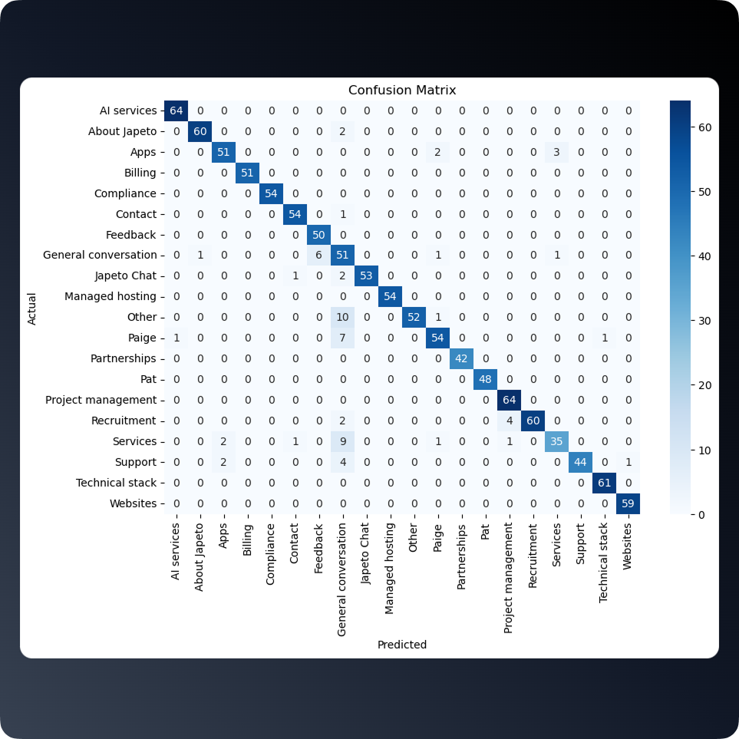The error matrix demonstrates how accurately the model categorises objects into the 21 classes. The values on the main diagonal represent the number of correctly classified objects for each class.

**Key observations**:

High accuracy for most classes

**For most categories**, the model shows high prediction accuracy - for example:

**Artificial Intelligence Services**: 64 out of 64 correctly classified.

**About Japeto**: 60 out of 62 right.

**Tech stack:** 61 out of 61 correct.

**Websites:** 59 out of 59 correct.

**Classes with minimal or no errors:**

Artificial Intelligence Services, Applications, Billing, Compliance, Contacts, Managed Hosting, Technical Stack, Websites.

**The most frequent**

Errors occur mostly between neighbouring classes:

**Support** → confused with **Services** (4 errors).

**Services** → confused with **Support and Feedback**.

**Page** → 7 correct, 3 errors on **Japeto Chat**, **Other** and **Sites**.

**Other** → 10 correct, 3 errors (1 on **Websites**, 2 on **Page**).

**Difficulties with class categorisation**

In some categories (e.g. General Chat, Other, Services, Support) the errors overlap with other classes. This may indicate overlapping message content or insufficient specification of data.

**Data distribution before and after balancing**

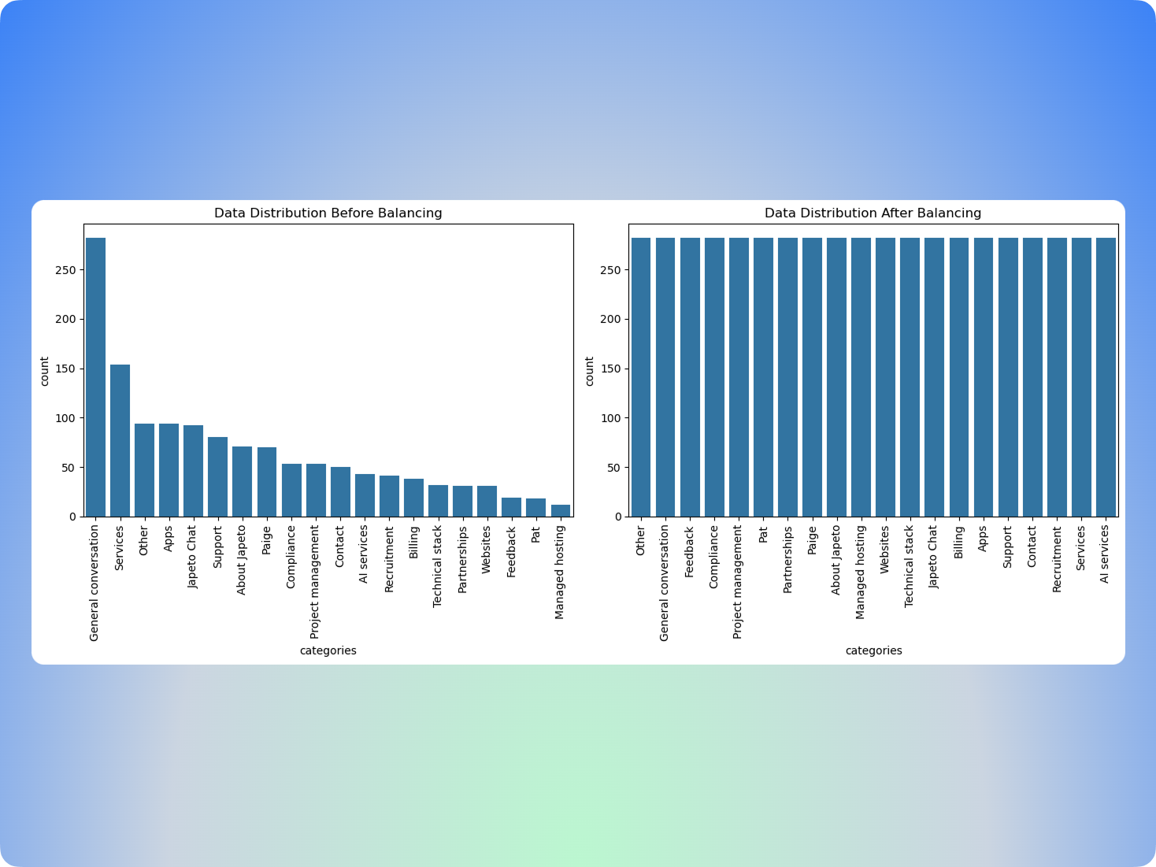**Overall conclusion**

Class balancing markedly improved the distribution of the data by providing a level playing field for all categories. This, in turn, allowed the model to learn more robustly and correctly categorise messages regardless of their initial frequency of occurrence.

**Full Code**

# 5 Training and Evaluating Models

[DELETE this text: In this section, you should describe which model/s you have chosen for your learning task. Give a brief introduction to the model and provide justifications for your choice.

What was your train-test split. Based upon your choices and data, you may explain some or all the followings:

* If you used Cross-validation technique
* What percent of training or test data you decided to use?]

**[Use at-least three different models.]**

## 5.1 Naive Bayes Classifier

**The Naïve Bayes classifier is a supervised machine learning algorithm that is used for classification tasks such as text classification. They use principles of probability to perform classification tasks.**

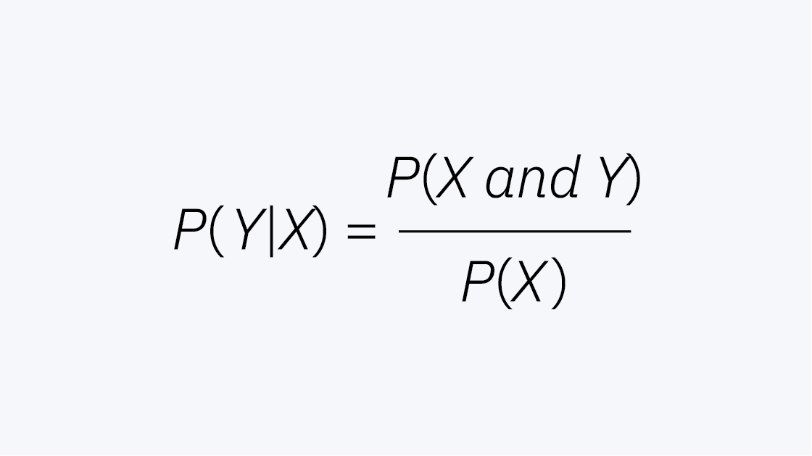Naïve Bayes is also known as a probabilistic classifier since it is based on Bayes’ Theorem. It would be difficult to explain this algorithm without explaining the basics of Bayesian statistics. This theorem, also known as Bayes’ Rule, allows us to “invert” conditional probabilities. As a reminder, conditional probabilities represent the probability of an event given some other event has occurred, which is represented with the following formula:

### 5.1.1 Evaluation design.

same type of data preprocessing as in my svm model

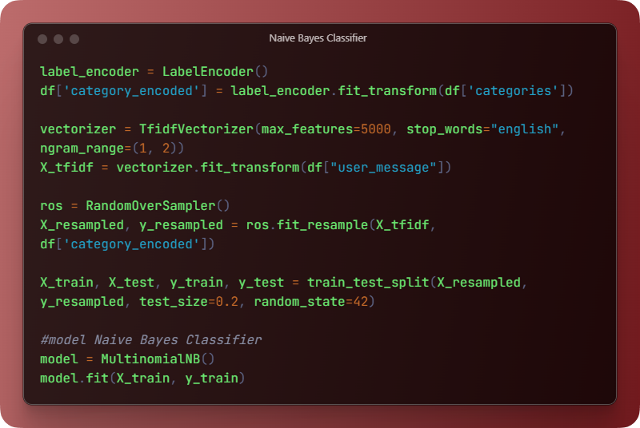**model = MultinomialNB()** - creates an instance of the model.

**model.fit(X_train, y_train)** - trains the model on X_train data and y_train target labels

**The MultinomialNB() model** is a multinomial naive Bayesian classifier. It is used to classify texts or other data presented as feature frequencies or feature counts (e.g., number of words in a text).

**How MultinomialNB** works:

**Based on Bayes' theorem**, which calculates the probability that an object belongs to a certain category based on the available features.

Assumes that all features are independent of each other.

It is suitable for discrete features such as the number of occurrences of words (bag of words, TF, TF-IDF, etc.).

### 5.1.2 Results.

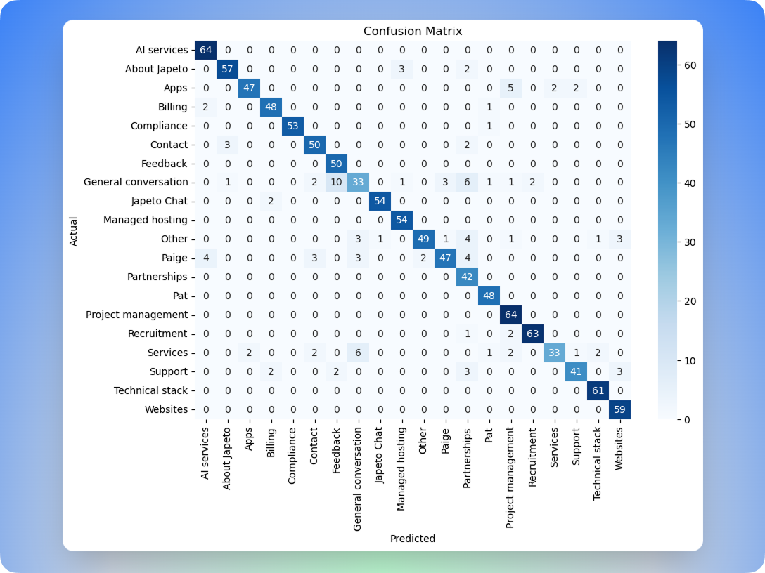Model Speed:

**Classification time for 1128 messages: 0.0011 seconds**  
**Average time per message: 0.000001 seconds**

**As you can see, this model also predicts about 90-93% accurately. And because of the simplicity of the calculation and the architecture of the model, it works almost instantly. but in category number 7 (recall = 58%, f1-score = 64%), there are strong gaps when comparing the SVM-based model.**

## 5.2 Logistic Regression

### 5.2.1 Describtion

**Logistic regression is a supervised machine learning algorithm that accomplishes binary classification tasks by predicting the probability of an outcome, event, or observation. The model delivers a binary or dichotomous outcome limited to two possible outcomes: yes/no, 0/1, or true/false**

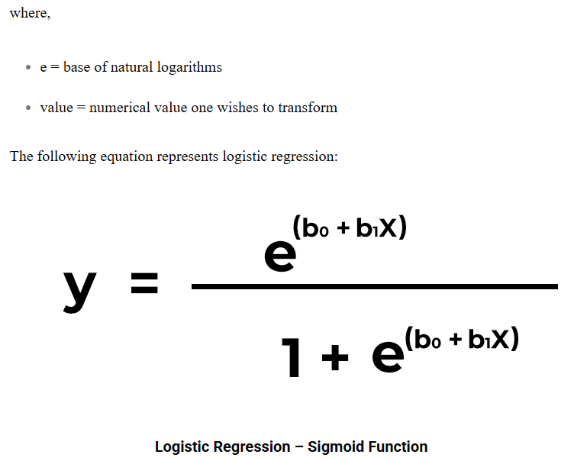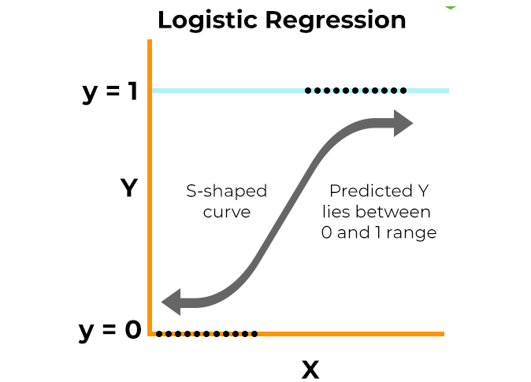**This equation is similar to linear regression, where the input values are combined linearly to predict an output value using weights or coefficient values.**

### 5.2.2 Explain your evaluation design.

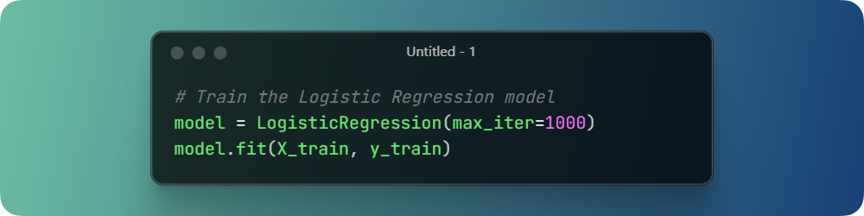**creates a logistic regression model. max_iter=1000 means that the algorithm will try to find the best settings in no more than 1000 iterations**

**Trains the model on training data X_train (attributes) and y_train (labels/responses).**

The code is exactly the same as the SVM and Naive Bayes Classifier models but the training type is set to logistic regression

### 5.2.3 Present and explain results.

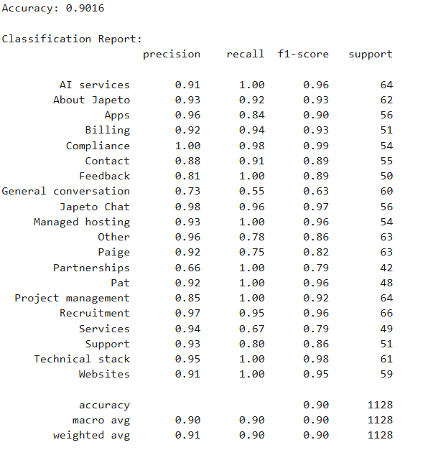

**Classification time for 1128 messages: 0.0015 seconds**  
**Average time per message: 0.000001 seconds**

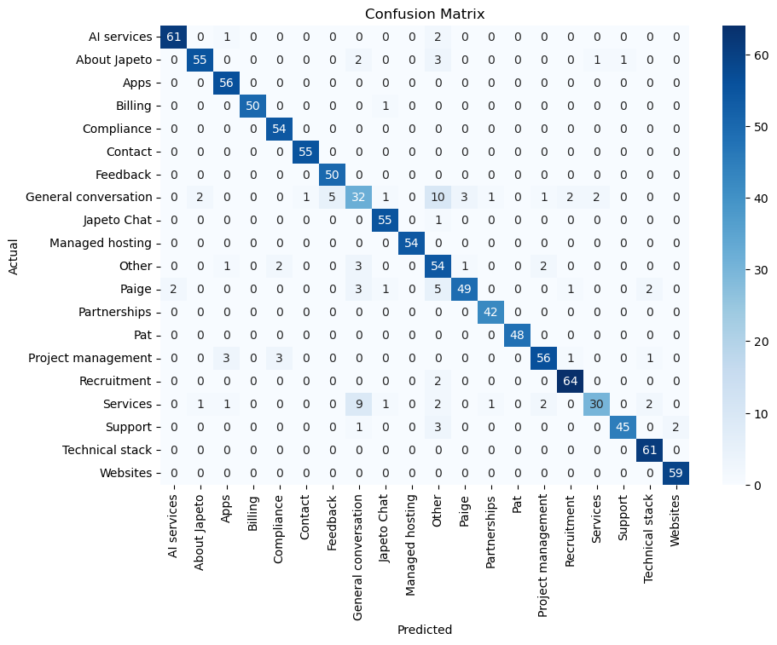pretty good results

## 5.3 Random Forest

### 5.3.1 Describtion

Random forest is a commonly-used machine learning algorithm, trademarked by Leo Breiman and Adele Cutler, that combines the output of multiple decision trees to reach a single result. Its ease of use and flexibility have fueled its adoption, as it handles both classification and regression problems.

Random forest algorithms have three main hyperparameters, which need to be set before training. These include node size, the number of trees, and the number of features sampled. From there, the random forest classifier can be used to solve for regression or classification problems.

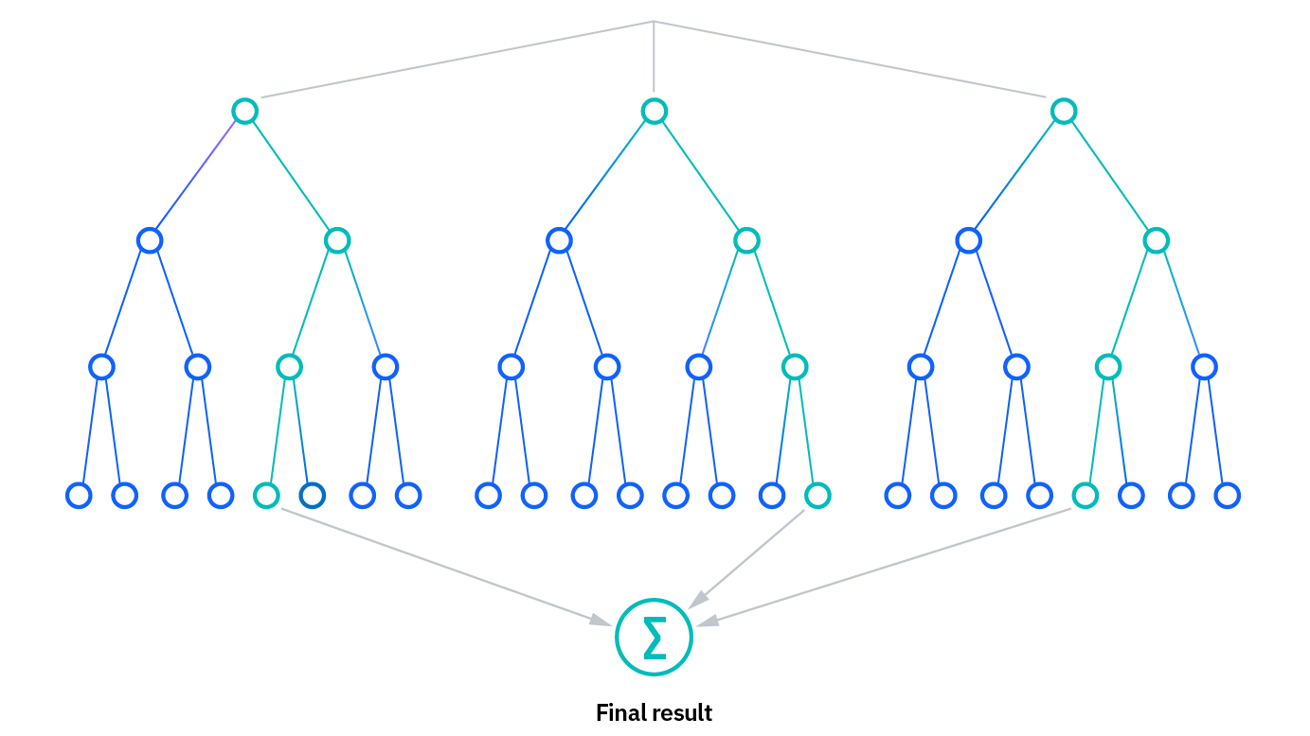

### 5.3.2 Explanation

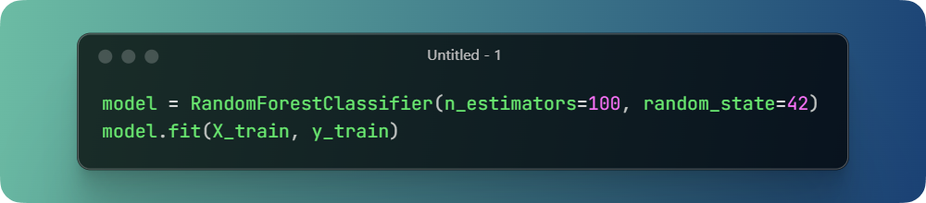

RandomForestClassifier(...) - creates a random forest model with 100 trees.

model.fit(X_train, y_train) - trains this model on data: X - messages, y - categories.

**For Random Forest model I also did not change anything such a simple type of text cleaning and also such a simple aforementioned type of training division (80% for training/20% for test).**

### 5.3.3 Present and explain results.

**Classification time for 1128 messages: 0.0362 seconds**  
**Average time per message: 0.000032 seconds**

Slightly slower than other models

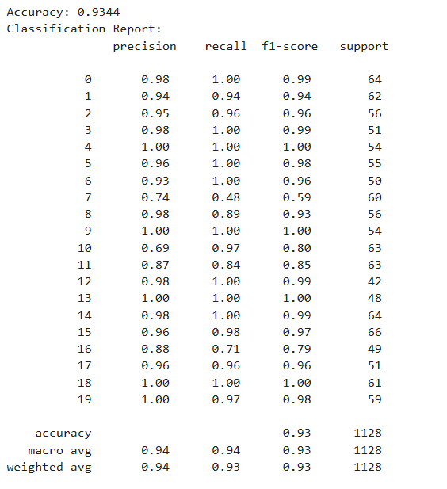

**Here too all is well stable graph where the model highly identifies the correct answers, but here too there are also strong gaps in point 7**

# 6 Evaluation Analysis

I didn't make any changes to the model, and it's already doing well — my worst model, the Naive Bayes model, got 90% accuracy. So, it's not worth changing anything. But at the beginning of the course, I searched for different information on Kaggle, I used neural networks to speed up information retrieval, and I discussed with the teachers the steps of model creation.

I can say that in the beginning, ChatGPT advised me to use a different library for vectorisation and text cleaning — for example, XGBoosting. It is quite a powerful Python library, but it's mainly for big data, and in our case, it would interfere with our model. (I used this Python library in the beginning and got an accuracy of about 60%.) Then I switched to a simpler model, which copes better.

**Model Comparison Tabel**

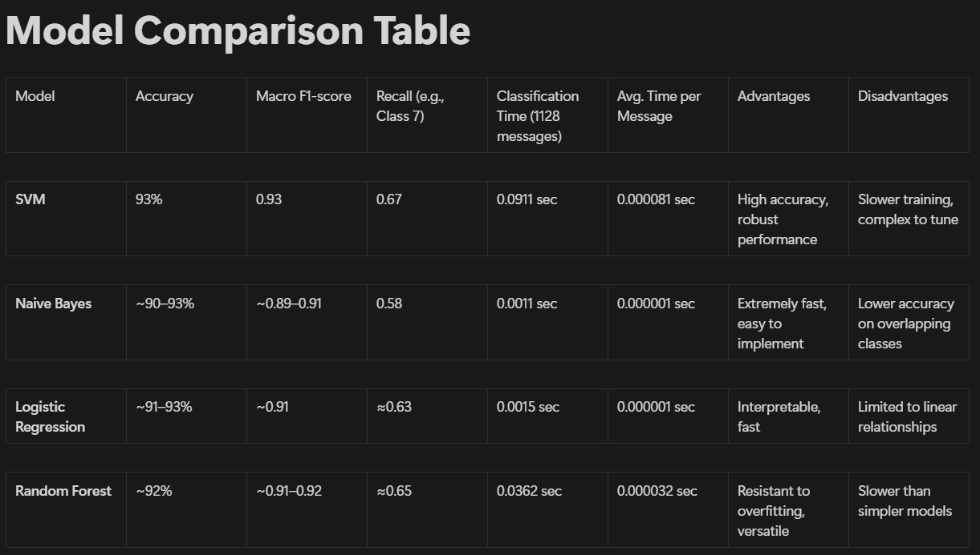

**Others**

**You may see a quote at the end of the project. I did this because I was inspired when I worked on it — just like the 19th-century and Renaissance scholars were inspired in their time.**

# 7. References

• IBM (n.d.) *Random forest*. Available at: <https://www.ibm.com/think/topics/random-forest> (Accessed: 2 April 2025).

• IBM (n.d.) *Naive Bayes*. Available at: <https://www.ibm.com/think/topics/naive-bayes> (Accessed: 28 March 2025).

• IBM (n.d.) *Support Vector Machine (SVM)*. Available at: <https://www.ibm.com/think/topics/support-vector-machine> (Accessed: 20 March 2025).

• Adnan, L. (n.d.) *NumPy Tutorial for Beginners - Data Science*. Kaggle. Available at: <https://www.kaggle.com/code/legendadnan/numpy-tutorial-for-beginners-data-science/notebook> (Accessed: 4 March 2025).

• Harris, C.R., Millman, K.J., van der Walt, S.J. *et al.* (2020) ‘Array programming with NumPy’, *Nature*, 585(7825), pp. 357–362. DOI: 10.1038/s41586-020-2649-2.

• Mode (n.d.) *Python Histogram Example*. Available at: <https://mode.com/example-gallery/python_histogram> (Accessed: 8 March 2025).

• Pandas Documentation (n.d.) *Pandas User Guide - 10 Minutes to Pandas*. Available at: <https://pandas.pydata.org/docs/user_guide/10min.html#operations> (Accessed: 8 March 2025).

• Codetoimg (n.d.) *Convert Code to Image*. Available at: <https://codetoimg.vercel.app/> (Accessed: 21 March 2025).

• Muhammad, I., Ullah, S., Ahmad, J. *et al.* (2022) ‘Text Classification Using Machine Learning Techniques: A Review’, *Computational Intelligence and Neuroscience*, 2022, Article ID 1862888. DOI: 10.1155/2022/1862888.